**Current Team**



[Dr. Weiyu Zhang](http://www.weiyuzhang.net)

Founder & Director; currently Associate Professor, Department of Communications and New Media, National University of Singapore

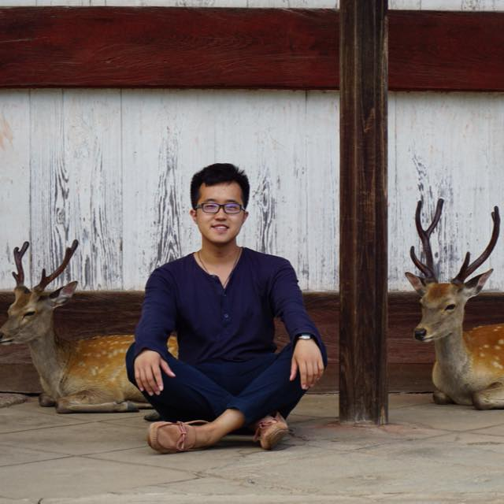

Zhuo Chen

PhD Candidate



Yipeng Xi

PhD Candidate

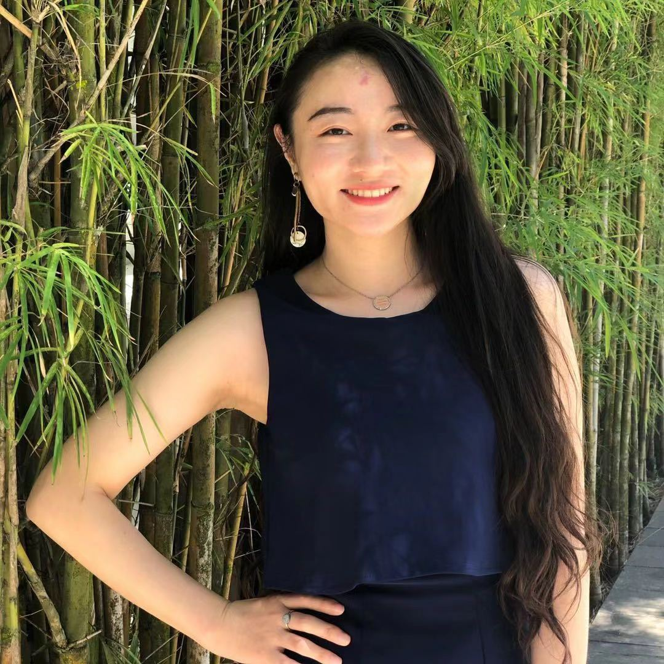

[Manjiang He](https://www.linkedin.com/in/manjianghe/)

Research Assistant, Master student, LKYSPP, NUS

Jason, Chin Seang Ng

Research Assistant, undergrad student, Mathematics, NUS

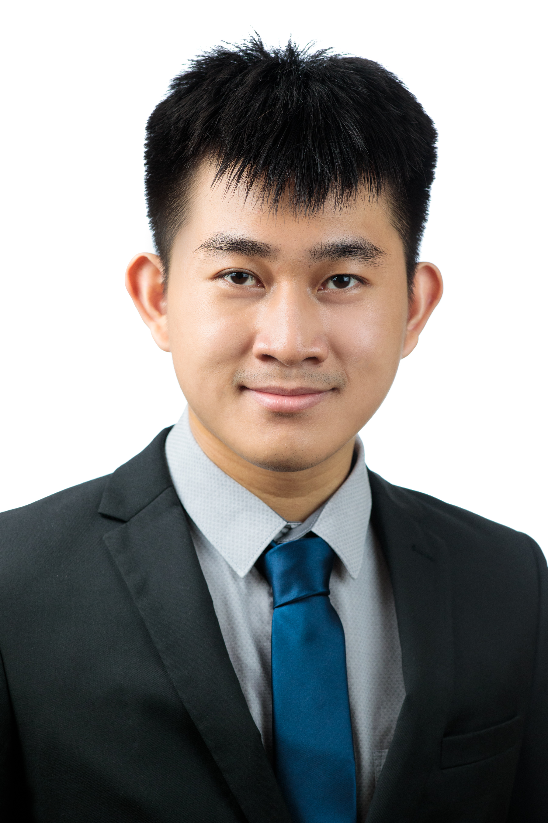

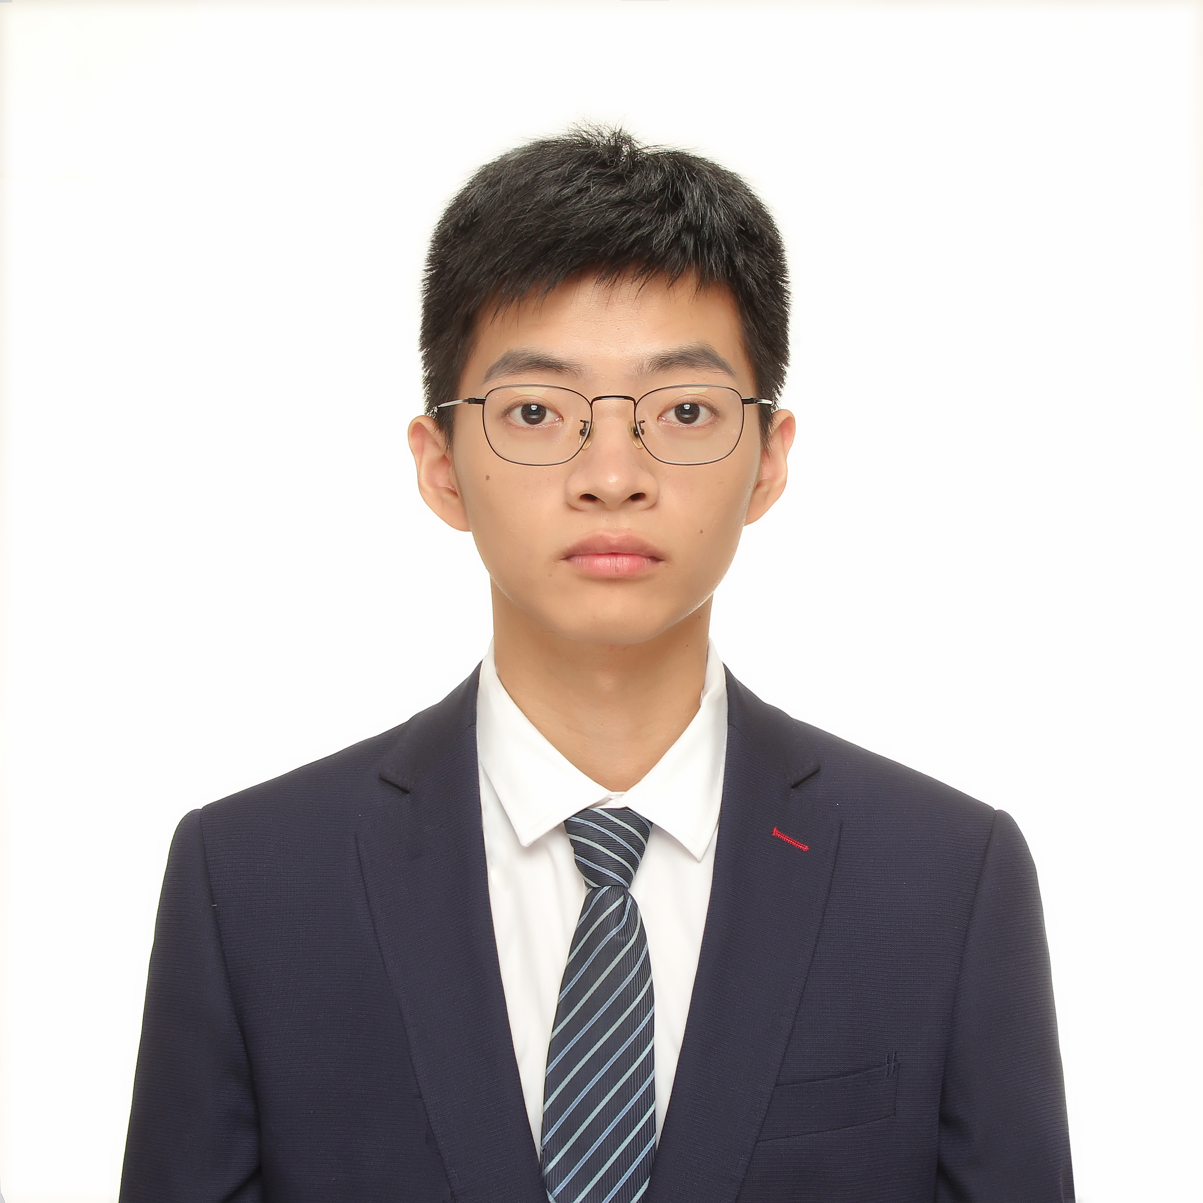

Haodong Liu

Research Intern, Master graduate, City University of Hong Kong



Huazhi Qin

Research Intern, Master graduate, Georgetown University

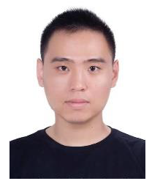

Tong Tong

Visiting PhD Student, Tsinghua University

**Alumni**



[Anfan Chen](https://www.researchgate.net/profile/Anfan-Chen)

Visiting PhD Student, Tsinghua University, 2019; currently PostDoc Researcher at Chinese University of Hong Kong (CUHK)



[Ximing Liu](https://www.linkedin.com/in/ximing-liu-951543b8/?originalSubdomain=cn)

Master Graduate, 2019; currently Market Researcher at Tencent



[Dr. Sanju Menon](https://www.linkedin.com/in/sanjumenonp/)

PhD Graduate, 2018; currently Data Scientist (Cognitive Automation) at UBS

  
Jingjing Liang

Master Graduate, 2018; currently taking a break

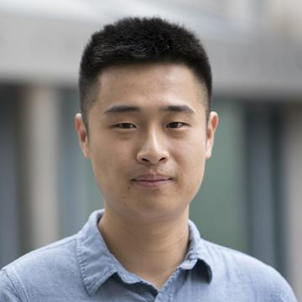  
[Tian Yang](https://www.asc.upenn.edu/people/graduate-student/tian-yang)

Master Graduate, 2017; currently doctoral candidate at University of Pennsylvania

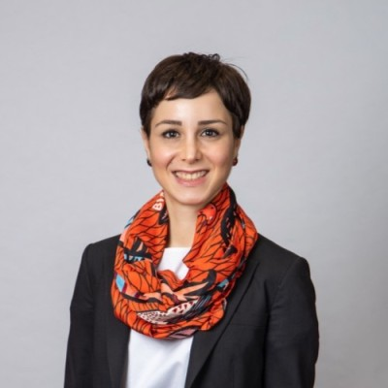

[Gulizar Haciyakupoglu](https://www.rsis.edu.sg/profile/gulizar-haciyakupoglu/)

PhD Graduate, 2016; currently ***Research Fellow at Nanyang Technological University***

  
Lize Zhang

Master Graduate, 2016; currently Founder of Peach Says



[**Dr. Simon Perrault**](https://istd.sutd.edu.sg/people/faculty/simon-perrault#biography)

**Postdoc Researcher, 2014-2015; currently Assistant Professor, Singapore University of Science and Technology**

  
[Jodie Luu](https://www.nus.edu.sg/celc/staff/jodieluu.html)

Master Graduate, 2013; currently Lecturer at National University of Singapore

  
Catherine Candano

Master Graduate, 2012; currently Head, Strategic Data Partnerships Development, Google Asia Pacific

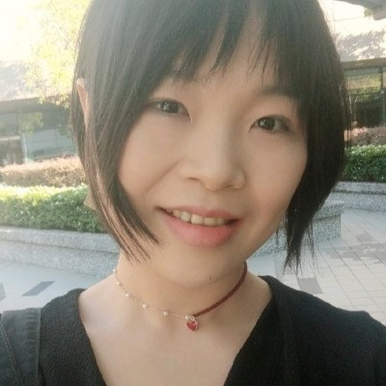

[Lingzi Zhang](https://www.linkedin.com/in/lizziezhang/)

Master Graduate, 2012; currently Product Director at Ola Chat